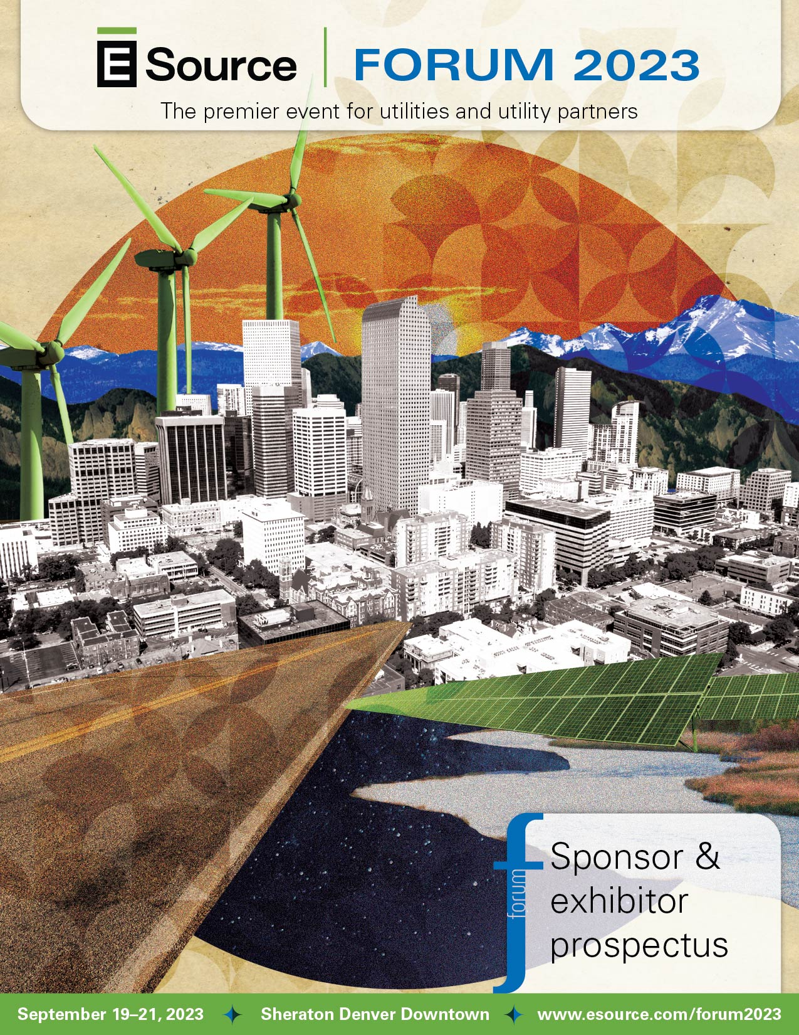800

**MEET FACE-TO-FACE  
WITH YOUR NEXT CUSTOMER**

**E Source Forum 2023**

September 19–21, 2023  
Sheraton Denver Downtown  
Denver, Colorado

**What Is the E Source Forum?**

For more than 36 years, the E Source Forum has facilitated learning, networking, and collaboration among utility professionals from across the US and Canada. Our agenda features topics that matter to you, with thought-provoking keynote speakers, market research and data-driven content, customer panels, and insights from your utility peers. In recent years we’ve hosted more than 800 utility professionals over the course of three days in downtown Denver.

**Forum draws 500+ utility professionals**

**EXHIBITOR  
INFORMATION**

**What’s Included**

* One 6-foot skirted table and two chairs for your organization’s table-top booth or stand-alone display of similar size
* One full registration to the E Source Forum, which includes access to all sessions unless otherwise noted
* After-hours security
* Your company’s name and logo displayed on:
  + Conference signage
  + The E Source Forum website and in the official Forum mobile app
  + Between-session advertisements, which run throughout the conference
  + The printed conference program
  + Attendee list with attendee name, title and company provided 30 days prior to the start of the event, one week prior to the start of the event, and within 3 business days, post-event. *Email addresses may be purchased for an additional $2,500 to be included on the post-event list.* Alternately, if your total spend (for booth and sponsorship) is $16,500 or more email addresses will be included in the post-event list at no additional cost.

|  |  |  |
| --- | --- | --- |
|  | **June 1 - July 31** | **Aug 1 - Sept 18** |
| **Premium table-top booth**  (numbers 1, 11, 18, 22, 29, 33; includes **2 attendees**) | $12,500 | $14,500 |
| **Member table** (includes **1 attendee**) | $8,500 | $10,000 |
| **Non-member table** (includes **1 attendee**) | $10,000 | $11,500 |
| **Additional in-person attendee\*** | $2,000 | $2,000 |

*Exhibitor packages include 1 or 2 registered attendees, and exhibitors may pay the additional

attendee fee to register up to 3 total attendees.

*Activities and times subject to change*

**Tuesday, 9/19:** Exhibitor set-up from 3:00 to 5:00 p.m.; Forum welcome reception in the in the exhibition area from 5:30 to 7:00 p.m.

**Wednesday, 9/20:** Exhibit floor open from 8:00 a.m. to 3:30 p.m.; Exhibitor-hosted cocktail hour from 6:30 to 7:30 p.m. in the exhibition area

**Thursday, 9/21:** Exhibit floor open from 8:00 a.m. to 4:00 p.m.; Exhibitor tear-down at 5:00 p.m.

**Exhibitor schedule**

**SPONSORSHIP OPPORTUNITIES**

******Platinum SPONSORSHIPS $16,500 each**

Includes 3 full Forum registrations

Your logo with recognition as a Platinum Sponsor on a sign displayed prominently in the main conference area

****Recognition as a Platinum Sponsor, with hyperlinked logo in the official Forum mobile app and on the Forum website



Your logo with recognition as a Platinum Sponsor included in our Forum program

Your logo with recognition as a Platinum Sponsor prominently displayed in our between-session advertisements, which continuously run throughout the conference

****Attendee list with attendee name, title and company provided 30 days prior to the start of the event and one week prior to the start of the event. Attendee list with attendee name, title, company, and email address provided within 3 business days, post-event

**SOLD! Everywhere sponsorship**This sponsorship includes escalator branding, elevator clings, and your logo on the badge lanyards.

**SOLD! Ping-Pong Party (Exclusive)**This sponsorship includes your logo displayed on signage at the venue and branded napkins.

**SOLD! Casino Night**This sponsorship includes your logo displayed on signage at the venue and branded napkins.

**SPONSORSHIP OPPORTUNITIES**

**gold SPONSORSHIPS $14,500 each**

****Includes 2 full Forum registrations with the option to purchase 1 more

Your logo with recognition as a Gold Sponsor on a sign displayed prominently in the main conference area

****Recognition as a Gold Sponsor, with hyperlinked logo in the official Forum mobile app and on the Forum website

Your logo with recognition as a Gold Sponsor included in our Forum program

You may provide one piece of marketing material to be displayed in the area

Your logo on signage at the event/station

Your logo with recognition as a Gold Sponsor prominently displayed in our between-session advertisements, which continuously run throughout the conference

****Attendee list with attendee name, title and company provided 30 days prior to the start of the event, one week prior to the start of the event, and within 3 business days, post-event

***Choose one below***



**Chair Massage (Exclusive)*  
Coffee CART (Exclusive)*  
Oxygen Bar (Exclusive)\***

**SOld! Professional HeadshotS (EXCLUSIVE)\***

**Caricature Artist (Exclusive)\***

**Lounge (EXCLUSIVE)\***



**\*These sponsorships are part of the Forum Mall.   
The Forum Mall will be open on Wednesday and Thursday beginning at 10:00 a.m.**

**SPONSORSHIP OPPORTUNITIES**

**silver SPONSORSHIPS $10,500 each**

Includes 1 full Forum registration with the option to purchase up to 2 more

Your logo with recognition as a Silver Sponsor on a sign displayed prominently in the main conference area

****Recognition as a Silver Sponsor, with hyperlinked logo in the official Forum mobile app and on the Forum website

Your logo with recognition as a Silver Sponsor included in our Forum program

You may provide one piece of marketing material to be displayed in the area

Your logo with recognition as a Silver Sponsor prominently displayed in our between-session advertisements, which continuously run throughout the conference

****Attendee list with attendee name, title and company provided 30 days prior to the start of the event, one week prior to the start of the event, and within 3 business days, post-event

***Choose one below***



**SOLD! water bottle sponsor**

**breakfast sponsor (2 available)**

**SOLD! welcome reception sponsor**

**lunch sponsor (2 available)**

**keycard sponsor (exclusive)**

**SOLD! welcome bag sponsor**

**notebook sponsor (exclusive)**



**SPONSORSHIP OPPORTUNITIES**

**bronze SPONSORSHIPS $8,000 each**

Includes 1 full Forum registration with the option to purchase up to 2 more

Your logo with recognition as a Bronze Sponsor on a sign displayed prominently in the main conference area

****Recognition as a Bronze Sponsor, with hyperlinked logo in the official Forum mobile app and on the Forum website

Your logo with recognition as a Bronze Sponsor included in our Forum program

***Choose one below***

Your logo with recognition as a Bronze Sponsor prominently displayed in our between-session advertisements, which continuously run throughout the conference

****Attendee list with attendee name, title and company provided 30 days prior to the start of the event, one week prior to the start of the event, and within 3 business days, post-event



**SOLD! Wi-Fi Sponsor  
AV SPONSOR (EXCLUSIVE)  
ReFreshment Break sponsor (4 AVAILABLE)**





**solutions showcase $8,000 each**

**This sponsorship includes:**

2 full Forum registrations with the option to purchase one additional registration at the additional-attendee rate

Your logo with recognition as a Solution Showcase Sponsor on a sign displayed prominently in the main conference area

Recognition as a Solution Showcase Sponsor, with hyperlinked logo in the official Forum mobile app and on the Forum website

Your logo with recognition as a Solution Showcase Sponsor included in our Forum program

The E Source Solution Showcase is an opportunity for you to share your expertise and be seen as a leader by hundreds of utility professionals. This year, the Solution Showcase will be part of the Forum agenda and will feature four concurrent topical sessions that attendees can choose from. The format will allow each solution provider (4 per session) to talk for up to five minutes about their solution, ideally in a case study format. These short presentations will be followed by a roundtable discussion hosted by an E Source expert. To reserve your spot, you will first need to submit a brief description of the case study you want to highlight. E Source reserves the right to accept or deny your submission.



You may provide a case study flyer to be distributed in the session

Your logo with recognition as a Solution Showcase Sponsor prominently displayed in our between-session advertisements, which continuously run throughout the conference

Attendee list with attendee name, title and company provided 30 days prior to the start of the event, one week prior to the start of the event, and within 3 business days, post-event













**sponsorship**

**PPORTUNITIES**

**logo SPONSORSHIPS (1 available) $6,000 each**

Includes 1 full Forum registration with the option to purchase up to 2 more

Your logo with recognition as a Logo Sponsor on a sign displayed prominently in the main conference area

****Recognition as a Logo Sponsor, with hyperlinked logo in the official Forum mobile app and on the Forum website

Your logo with recognition as a Logo Sponsor included in our Forum program

Your logo with recognition as a Logo Sponsor prominently displayed in our between-session advertisements, which continuously run throughout the conference

****Attendee list with attendee name, title and company provided 30 days prior to the start of the event, one week prior to the start of the event, and within 3 business days, post-event

**private meeting space Add-On (4 available) $11,500 each**

This is an exclusive opportunity for exhibitors to reserve a private meeting space–conveniently located adjacent to the exhibit floor–for the duration of the Forum. The space will give you an opportunity to meet with current and prospective clients in a more private setting, perfect for demos or small group client meetings. Includes:

Exclusive use of a private meeting space (see map on p. 10; Plazas 1 through 5)

Signage with your logo outside the meeting space

One full Forum registration*

*Two additional registrations may be purchased at the additional-attendee rate

**EXHIBITOR & SPONSOR  
RESERvATION FORM**

**attendee list email address upgrade $2,500 each**

Email address may be purchased for an additional $2,500 to be included on the post-event list. Alternately, if you are a platinum sponsor or if your total spend (for booth and sponsorship) is $16,500 or more, email addresses will be included in the post-event list at no additional cost.

**Fill out pp. 9–12  
and return to  
emily_roberson@esource.com**

**EXHIBITs**

**Yes!** We would like to be a 2023 E Source Forum exhibitor

**Yes!** We would like to purchase the upgraded attendee list with email addresses

|  |  |  |
| --- | --- | --- |
|  | **June 1 - July 31** | **Aug 1 - Sept 18** |
| **Premium table-top booth**  (numbers 1, 11, 18, 22, 29, 33; includes **2 attendees**) | $12,500 | $14,500 |
| **Member table** (includes **1 attendee**) | $8,500 | $10,000 |
| **Non-member table** (includes **1 attendee**) | $10,000 | $11,500 |
| **Additional in-person attendee\*** | $2,000 | $2,000 |
| **Attendee list email address upgrade** | $2,500 | $2,500 |

*Exhibitor packages include 1 or 2 registered attendees, and exhibitors may pay the additional

attendee fee to register up to 3 total attendees.

**Exhibit Table Selection.** Indicate your top three booth selections:

(1) #       ; (2) #      ; (3) #

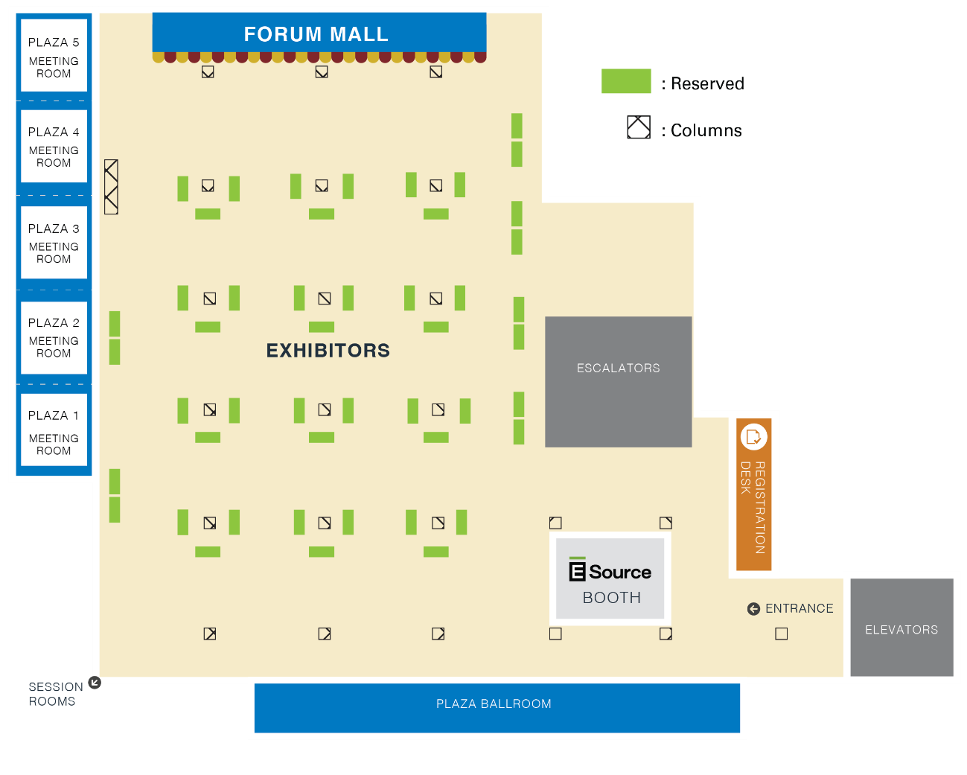

1

6

7

5

10

9

4

8

3

2

11

15

14

17

16

13

12

19

21

20

22

18

PLAZA 1

ROOM

SOLD

32

26

24

27

25

31

29

28

23

30

33

39

35

37

36

38

34

41

42

40

**EXHIBITOR & SPONSOR  
RESERVATION FORM**

**SPONSORSHIPS**

**Yes!** We would like to be a 2023 E Source Forum sponsor

**Yes!** We would like to purchase the upgraded attendee list with email addresses for $2,500

**Sponsor prices increase effective August 1st**

**Platinum sponsorships:** $16,500 each

**SOLD!** The everywhere sponsorship  
 **SOLD!** Ping-pong party  
 **SOLD!** Casino night

**Gold sponsorships:** $14,500 each

Chair massage

Coffee cart

Oxygen bar  
 **SOLD!** Professional headshots

Caricature artist

Lounge

**Silver Sponsorships:** $10,500 each

**SOLD!** Water bottle sponsor

Breakfast sponsor (2 available)

**SOLD!** Welcome reception sponsor

Lunch sponsor (2 available)

**SOLD!** Welcome bag sponsor

Notebook sponsor

Key card sponsor

**Bronze Sponsorships:** $8,000 each

**SOLD!** Wi-Fi sponsor

AV sponsor

Sponsors may register a total of three attendees. Please refer to your sponsorship level for more details. If you’re also an exhibitor, you may register three additional attendees.

Refreshment break sponsor (4 available)

**Solutions showcase:** $8,000

**Logo sponsorships:** $6,000 (1 available)

**Private meeting space:** $11,500 each (4 available)

**In-person attendee:** $2,000 each

**EXHIBITOR & SPONSOR  
RESERVATION FORM**

**Internal Logistics Contact**

Name        
Email       Phone

**PAYMENT INFORMATION** Enclosed is a check payable to E Source

Please charge my credit card

Please send me an invoice

Card number

CVV code from back of card

Expiration date

Amount to charge $

Name as it appears on card

Billing address

Cardholder signature

TERMS AND CONDITIONS FOR EXHIBITORS AND SPONSORS

1. Payment policy: Payment terms are net 30 from the date of the signed application. If full payment is not received on or before September 1, 2023, E Source has the authority to release the booth/sponsorship for resale.

2. Cancellation policy: Exhibitor/sponsor cancellations must be received in writing on or before June 21, 2023, to receive a refund. Cancellations received after  
June 21, 2023, or no-shows will not receive a refund. Exhibitor/sponsor agrees to these conditions as part of a contract for exhibit space/sponsorship. Substitutions within your organization may be arranged at any time.

3. Booth placement: Booth selection will be offered on a first-come, first-served basis.

4. Use of exhibit space: All demonstrations or other activities must be confined to the limits of the booth and not impede traffic or interfere with other exhibit displays. Exhibitor shall not assign, share, or sublet any space allotted without the written consent of E Source management.

5. Distribution of circulars or promotional material: Materials may be distributed only within the booth assigned to the exhibitor presenting the material. Circulating or handing out promotional materials outside of an official Forum exhibit/sponsorship is prohibited.

6. Use of hotel meeting rooms: The use of on-site rooms for client meetings, technology demonstrations, or other business activities during the 2023 E Source Forum is prohibited.

7. All participating E Source Forum sponsors and exhibitors agree not to schedule any competing social or related activities during Forum hours, including evening hours when there are scheduled functions that are part of the official Forum program. If your company intends to host any activity or meal, you must seek permission from E Source prior to planning the event to ensure it doesn’t compete with other Forum activities.

8. The E Source Forum is a closed event. Attendance is open only to our utility members, supporting utility partners, and other utility industry professionals at the discretion of E Source management.

9. The E Source Forum is a unique utility industry event. The event and its program are designed to provide an outstanding customer experience for all Forum participants, including utility and solution provider staff. E Source management reserves the right to deny future event participation for any attendee who chooses not to follow the Forum rules and guidelines.

10. In the event your company is acquired by another company after you have paid for an exhibit booth or sponsorship, you may redistribute that exhibitor/sponsorship fee to another opportunity at the same event (for example, if you paid for an exhibitor booth, you may request that your fee be applied to a sponsorship under the new company name instead). Any changes made by exhibitors and sponsors, including the scenario described above, or withdrawal from the event is subject to our cancellation policy.

11. All registrants for your exhibit/sponsor package must have the same email domain.

By signing here I accept the E Source Terms and Conditions.

Signature

**CONTACT US**

If you need help or more information, call us at 1-800-ESOURCE (1-800-376-8723), email events@esource.com,  
or visit www.esource.com/forum2023.

**EXHIBITOR & SPONSOR  
RESERVATION FORM**

**Exhibitor & Sponsor Attendee Registration Information**

Name

Title

Company

Phone

Email

Name

Title

Company

Phone

Email

Name

Title

Company

Phone

Email